***SUBMITTED BY:***

*BILLAL HOSSEN*

*ID:171442524*

*BATCH:44TH*

*PROGRAM: CSE(DAY)*

***SUBMITTED TO:***

*PRANAB BANDHU NATH*

*SENIOR LECTURER*

*DEPARTMENT OF CSE*

*CITY UNIVERSITY*

* ***ADVANTAGE:***

1. **Easy to manage and maintain the network because each node requires separate cable.**
2. **Easy to locate problems because cable failure only affects a single user.**
3. **It provides very high speed of data transfer.**
4. Easy to connect a computer or peripheral to a linear bus.
5. Easy to extend the network without disturbing to the entire network.

* ***DISADVANTAGE:***

1. Entire network shuts down if there is a break in the main cable.
2. Difficult to identify the problem if the entire network shuts down.
3. It can be hard to troubleshoot individual device issues
4. If a main cable is damaged, the network fails or splits into two.
5. Additional devices slow the network down.

|  |  |  |  |
| --- | --- | --- | --- |
| PRICE OF COMPONENTS | | | |
| SL NO. | EQUIPMENT | QUANTITY | PRICE |
| 01 | COMPUTER(HP) | 40 | 1400000 |
| 02 | SERVER (HP ProLiant ML350) | 2 | 780000 |
| 03 | SWITCH (CISCO SF95-24) | 20 | 90000 |
| 04 | D-LINK CAT6 CABLE | 5 BOXES | 57500 |
| 05 | CONNECTOR (RJ45) | 100 | 2200 |
| 06 | ROUTER (Cisco SG300-28SFP) | 1 | 56000 |
| 07 | CRIMPER | 2 | 2000 |
| 08 | CABLE TESTER | 2 | 1800 |
| 09 | HP LASERJET PROFESSIONAL CP5225DN COLOR PRINTER | 10 | 1950000 |
| TOTAL PRICE=4339500 | | | |

* ***SCAN ME***



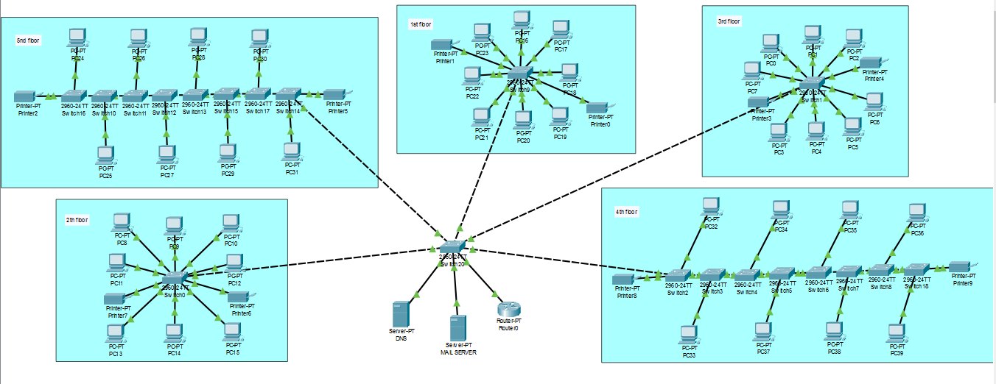

LOGICAL DIAGRAM